# The Modifier Key in AARAE

## What is the modifier key?

The modifier key is the key that modifies the behaviour of elements in AARAE’s graphical user interface (GUI). Up until AARAE release 7, it was the ‘shift’ key. However, after release 7 it was changed to the ‘Alt’ key (on PC) or the ‘Option’ key (on Mac). This change was made to disambiguate the function of the key when shift was being used for multiple selection.

## What does the modifier key do?

The following applies to recent versions of AARAE (after, and not including, Release 7), because the function of the modifier key was significantly expanded.

### Visual display of Audio2 (if present)

In AARAE, many generators write a secondary audio field, called audio2. In many cases, this is the test signal’s inverse filter. If you click on one of the two charts in the main GUI, this creates a separate figure based on the plot content. If you use the modifier key when you click on the chart, this creates a separate figure representing the audio2 field (using the same format as the chart you clicked on) instead of the audio field. For example, the following Figure1 was generated this way (by option-clicking on the upper GUI chart on a Mac).

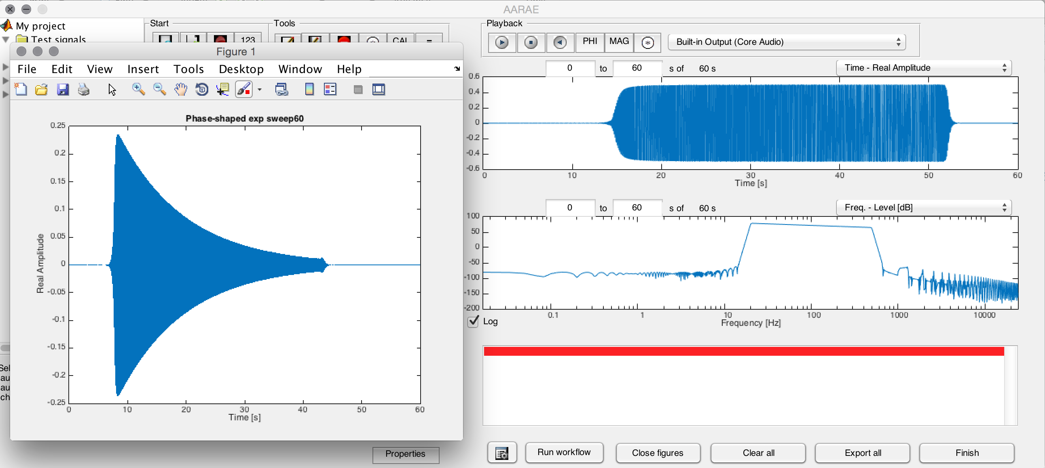

If audio2 is not present, then the new figure displays the audio field instead.

This functionality is not new.

### Listening to Audio2 (if present)

If audio2 is present, you may listen to it by using the modifier key in conjunction with the playback buttons in the main GUI. This applies to all five of the playback buttons.

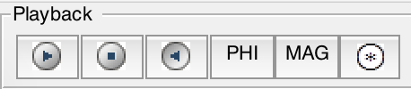

If audio2 is not present, then audio is played instead.

### Accessing Audio2 (if present) for comparison plots (=)

The audio comparison tool of AARAE (the ‘=’ button) has been greatly expanded in (and after) Release 7. If audio2 is present in any of the selected audio, and the modifier key is used with the button, then audio2 will be displayed in the comparison plots (instead of the primary audio field). For example the following shows the audio2 fields of two sinusoidal sweep signals (normalized).

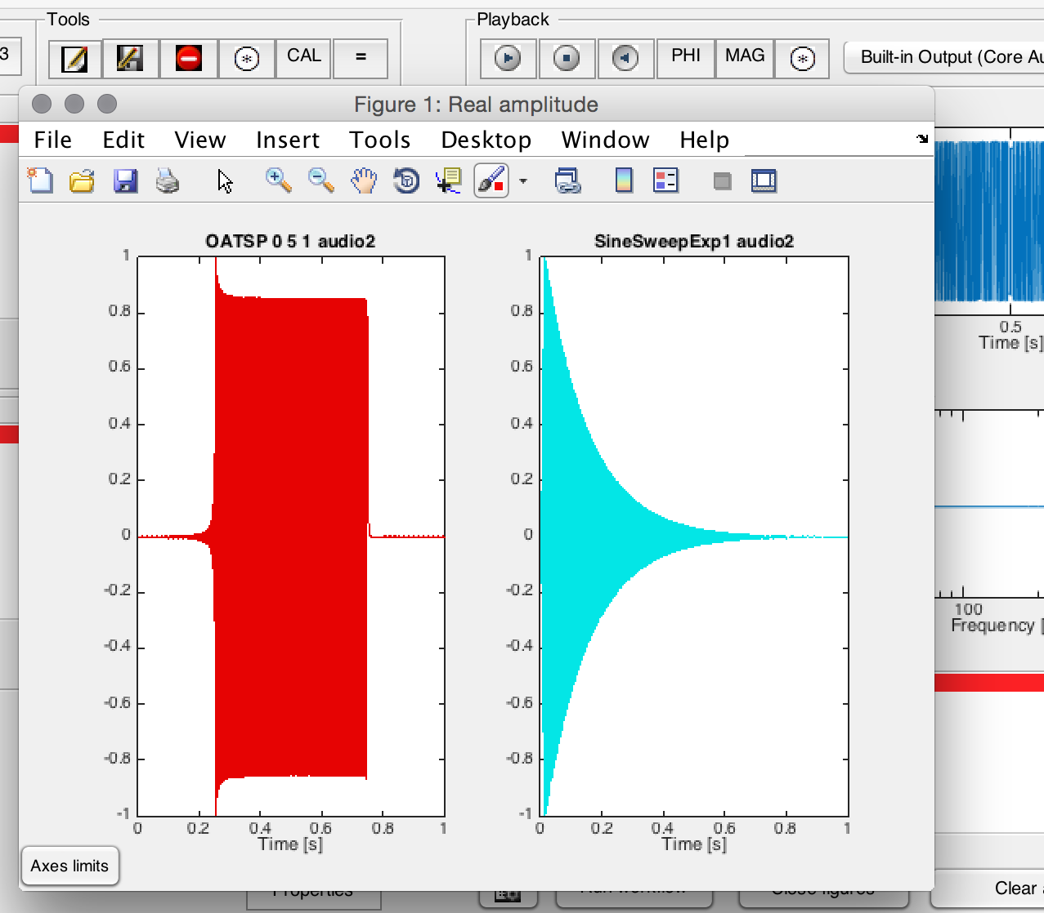

### Exchanging Audio and Audio2 when recording

Using the modifier key, you can swap the audio and audio2 of the selected test signal when you press the record button. This is primarily useful for educational experimentation: because while the resulting impulse response would ideally be the same regardless of which is used as the signal and which as the inverse filter, results may be different due to suboptimal signal to noise ratio and other issues. In the example below, the inverse filter of an exponential sine sweep is used as a test signal, and this is highly likely to yield suboptimal results.

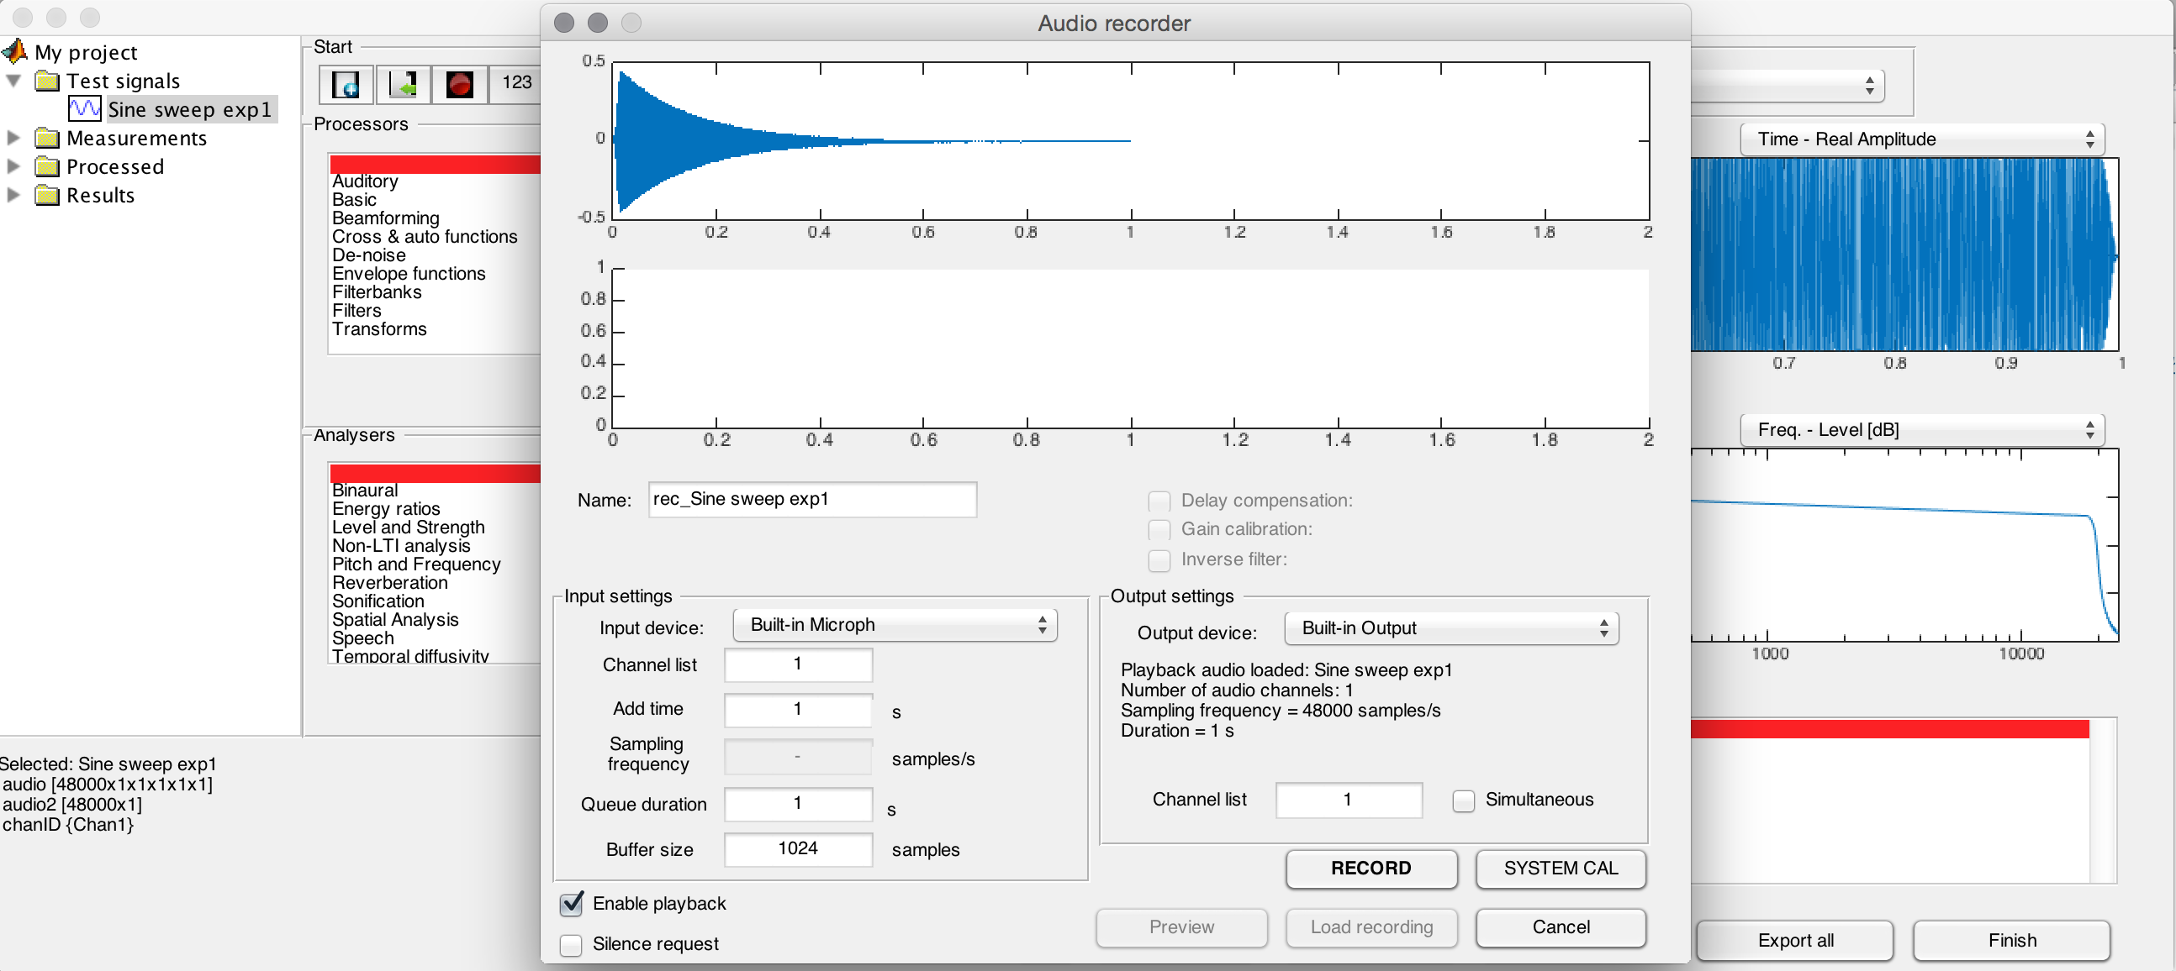

### The convolve Audio with Audio2 button (*)

When the modifier key is pressed together with the * button, a range of operations is made available (all combining audio with audio2). This includes cross-correlation, circular processing, and transfer function processing that is conceptually equivalent to deconvolution (but more practical than literal deconvolution).

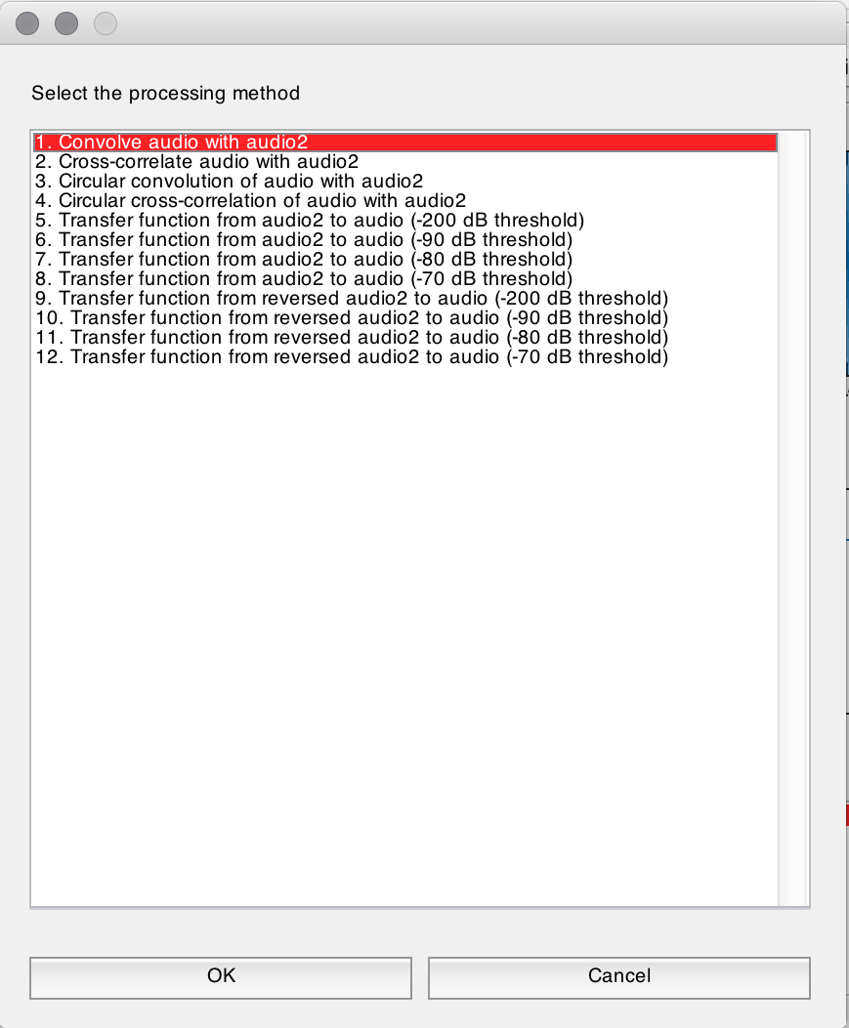

### Reliability of the modifier key

The modifier key is not completely reliable – sometimes when it is pressed, AARAE does not register that it has been pressed. I am not sure if there is a solution to this (other than trying again).